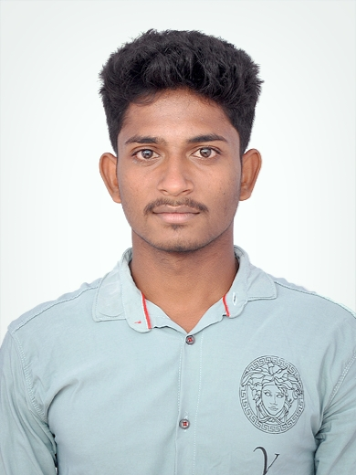

PROFESSIONAL SUMMARY
An independent and self-motivated business student with proven and tested business, procurement, sales, and marketing skills. An award-winning and confident communication graduate, able to establish rapport quickly and conduct training sessions with clarity and enthusiasm.
KEY SKILLS
Digital Marketing | MS Excel

KEY POSITIONS HELD
Coordinator| Sport Club, TPGIT| 2019
Captain| Cricket Team, School | 2015

ACHIEVEMENTS
Best Student | School | 2015
First Runner | TPGIT | 2017
AREAS OF INTEREST
Reading, Gaming, Business , Photography.
PERSONAL DETAILS
D.O.B- 23/04/2001
Address – 621/2 Rangapuram village
Palur (post) Ambur(Tk) Pin (635804)
Languages Known- English, Tamil, Telugu.

SHOGITHMANJUNATH M
shogithchowdary@gmail.com | +91-6383035851
ACADEMICS

- BCA| K.M.G Arts and Science |2018-21|per:7.2 %
- 12TH | Govt. Boys Hr. Secondary school | 2016-17 | per : 48%
- 10TH | Govt. Boys Hr. Secondary school | 2014-15 | Per : 79%

INTENTSHIP
- Digital Marketing | Intershala |
- The Training consisted of Bogging & web analysis search engine Optimization ,Email marketing
- Inbound and content marketing

CERTIFICATIONS
- Boxing District Runner in Vellore 2019

EXTRA CURRICULAR ACTIVITIES
- Volunteer ship
- Volunteer Donate a blood in KMG campus.
- BSM promoted to the office and volunteer Getting Leads in my team
- Events
- Participated in Division level Running race - won a 2nd price TN Board | AUG 2016
- Participated in – Division level cricket tournament at Madhanur .

WORK EXPERENCE

BPO (BUINESS PROCESS OUTSTANDING) TELE COMMUNICATION

- Position of the company BSM
- Client management involves dealing with patient grievances.
- Legal handling and settlements -1
- One year of experience in this sector
- Oct 2021 to Oct 2022

